TECHNICAL REQUIREMENTS

FOR THE

MULTI-LEVEL OIL INDICATOR
AUTOMATED OLS TEST BENCH

ALLEN AIRCRAFT PRODUCTS, INC.

REPORT #250129

PREPARED BY:
Rick Ales, R. Ales Consulting LLC

REVIEWED BY:
George J. Bush, Chief Engineer

APPROVED BY:
Rob Hyde, Engineering Manager

ALLEN AIRCRAFT PRODUCTS, INC.

RAVENNA, OHIO

RECORD OF REVISIONS
REV. | DESCRIPTION | DATE | AUTHOR
Draft 1 | Initial Draft | 2024/02/07 | R. Ales
Draft 2 | User Case 5: Changed the Test method to more align with current ATP procedure.  5.1.4 Change pump controller to three speed servo. | 2024/07/23 | R. Ales
Draft 3 | Overhaul to reflect state of the project on 3/1/25 | 2025/03/01 | R. Ales
Draft 4 | Change the definition of the Epics.  Numbered the requirements eg. 1) | 2025/03/17 | R. Ales
Draft 5 | Updated Document Format. Minor updates | 2026/08/27 | G. J. Bush
Draft 6 | Aligned requirements to the QTP document | 2026/09/23 | R. Ales

Table Of Contents
Paragraph Page

1.0 Introduction 4
1.1 Reference Documents: 4
1.2 Notation 4
1.3 Allen Aircraft Products Agile Project Management Glossary: 4
2.0 MOLI Project Overview: 5
3.0 EPIC 1 5
3.1 Production Tester User Story 6
3.2 Maintenance User Story 6
3.3 Hardware Inputs: 6
3.4 Hardware Outputs: 6
3.5 HMI: 7
3.6 Use Case 1: Load Test Plan -- Maintenance User 7
3.7 Use Case 2: Validate Test System -- Maintenance User 8
3.8 Use Case 3: Read Test Configuration -- Production Test User 8
3.9 Use Case 4: Initialize DUT test -- Production Test User 8
3.10 Use Case 5: Run DUT Test -- Production Test User 9
3.11 Use Case 5: Generate DUT Test Report -- Production Test User 11
4.0 EPIC 2 11
5.0 APPENDIX A NOT PART OF THIS SPECIFICATION 12

- Introduction
The following document sets forth the requirements of the Multi-Level Oil Indicator (MLOI) program for automating acceptance testing of oil level sensors. The MLOI program is divided into phases, or epics. The first epic automates production testing of the Allen 8005571.05 (P&WC 30Y0241-01) Oil Level Sensor, specifically the Oil Level Test Bench protocol defined in the ACCEPTANCE TEST PROCEDURE FOR ALLEN 8005571.05 (also called the Elevation OLS ATP).

This document shall be the source of testable requirements traceable to the companion Qualification Test Plan (QTP), under which the equipment will be validated and verified as fit for use in production.
  - Reference Documents:
ACCEPTANCE TEST PROCEDURE FOR ALLEN 8005571.05, Report# 200333
  - Notation
- Means Informative
- Means Requirement
LV LabVIEW
AAP Allen Aircraft Products
QUAM AS9100 Quality Manual
ATP Acceptance Test Procedure
OLS Oil Level Sensor
CIP Custom Interface PCB
DUT Device Under Test
AI Analog Input
XL MS Excel
MLOI Multi-Level Oil Indicator, designation of the automated tester described herein.
SHALL Absolute Requirement
MAY Permissive Requirement
  - Allen Aircraft Products Agile Project Management Glossary:
Agile: Project management as an iterative approach to delivering a project, which focuses on continuous releases that incorporate customer feedback.
Epic: Project as part of a program defined by one or more User Stories.
User Story: Description of the end goal of an Epic from the user’s perspective.
Use Case: Describes the system or user steps in a process to generate testable requirements that can be turned into executable tasks.
Backlog: List of tasks derived from Use Cases
Scrum: Sprint meeting to prioritize task execution from the backlog and plan deliverables.
Sprint: Small work cycle or iteration intended to execute Scrum tasks and deliver content.
Kanban board: Planning tool for visualizing work in progress divided into stages, typically Requirements Definition, Design, Development, Test, and Release.
Standup: Frequent, brief meeting to address immediate needs to execute the Sprint.
Sprint review: Meeting to approve transition to next Sprint by verifying the completion of Sprint deliverables. (Developers merge branch into main, Test new main code.)

- MOLI Project Overview:
The LV programming project objectives are divided into phases, or epics, each suitable for release to production, as follows:
- Epic 1 -- Single DUT automated test
- Epic 2 – MLOI capability extended to accommodate other OLS product lines.
- Epic 3+ – Uses the Custom Interface PCB (CIP). The MLOI capability may also be extended to accommodate testing multiple sensor DUTs simultaneously.
The project hardware including the tank, pump and instrumentation also has two phases as follows:
- HW 1 – Prototype phase where all items are COTS and custom configurations are achieved through breadboards or otherwise temporary connections.
- HW 2 – Production phase, in which custom interfaces have been designed and implemented for their intended purpose; for example, an interface unit manufactured as a custom PCB.
- Both the LV application code and HW shall be version controlled.
- Version control follows a major/minor convention. The major revision is designated by a letter: Q indicates an evaluation version, and letters beginning with A indicate a production release. The minor version is designated by a sequential number indicating the next revision that is compatible in form, fit, and function with the major production revision.
- The system shall have distinct modes, Test and Maintenance.
- The objective is to restrict casual test operators from modifying the test while allowing a technician in Maintenance mode to tune or calibrate the system.
- EPIC 1
EPIC 1 is a fully functional system capable of testing a single DUT, the PWC Elevate OLS device (PN 8005571.05), over the test cycle described in the following use cases.

- The EPIC 1 System MAY be placed into production service with the HW1 (breadboard) hardware.

  - Production Tester User Story
The Production Operator’s objective is to conduct the test and generate a Pass/Fail Acceptance Test Report for the DUT containing product information and test status. An overview of the MLOI Test Operator use case is illustrated here.

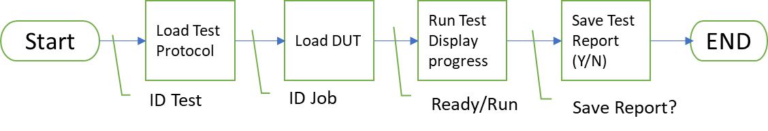
Figure 1. MLOI System Block Diagram

The Operator starts the application, selects the test configuration, enters the required test information, loads the single DUT, runs the test, and may then print the results. The Operator may set various levels and read the OLS response to investigate suspect results, then decide whether to rerun the test or reject the DUT.
  - Maintenance User Story
The Maintenance User maintains the apparatus. This may include loading a new test configuration, performing system maintenance such as extensive calibration, conducting capability studies, or tuning the system response. The Maintenance User may wish to evaluate the application software and hardware separately. The Maintenance User also installs and updates system components.
  - Instruments and Motor Controller
- The hardware instrument and motor controller statuses shall be indicated as follows: Green = Good to test; Red = Bad or Fault; Yellow = Needs attention or not automatic (e.g., simulation mode).
  - Hardware Inputs:
- ChA and ChB resistance measurement 0-1700Ω +/- 1%
- ChA and ChB Current Source 14.7 mA +/- 0.05%
- Resistance measurement calibration check shall be enforced monthly.
- Level measurement (Process Variable PV) 2.5 to 8.5 inches +/- 0.0005”
- Level measurement calibration check shall be enforced daily
  - Hardware Outputs:
- Level control (Set Point SP) 2.5 to 8.5 inches +/- 0.002”
- Level control assessment shall be enforced annually.

  - HMI:
- Shall provide a one-button means for starting the automated test.
- Shall provide a means to manually control the Tank Level.
- Shall display the current ChA and ChB measurement to 0.1Ω
- Shall display the level measurement to 0.001”
- Shall provide a time-based plot of the resistance for both ChA and ChB and the tank level.
- Shall display instrument status.
- Shall display the Pass/Fail status and progress of the test.
- Shall provide a menu means to launch secondary methods.
- Shall not require the operator to enter redundant information.

  - Use Case 1: Load Test Plan -- Maintenance User
    - Document management
- The test plan shall be an XL workbook named so that it is traceable to the test protocol implemented.
- The test plan shall be version controlled in the Test repository per AAP QUAM.
- There shall be a means to add/include the test plan path into the user prompt.

    - Enter the test bench configuration parameters into XL test plan.
- The test plan shall contain the configurable test bench parameters as determined by the test bench design.
- Tabular data should be copied and pasted from the reference Test Document (ATP) into the XL Test Plan document for loading as an LV parameter.

    - Enter DUT specific configuration parameters into XL test plan.
- The test plan may eventually include variations of the test protocol run at different stages of production. Examples include setting the switch assembly depth, a pre-pot test in which the DUT has flying leads, and a post-pot test using the connector in the actual ATP.
- The test plan shall contain the referenced test protocol test bench parameters as determined by the test bench design.
- The test bench parameters should be copied and pasted into the XL Test Plan document.
- The Test Plan shall contain a template of each test report generated on a separate sheet in the test plan XL workbook.
- The test plan shall be capable of containing multiple templates to accommodate recording multiple test points or variations of test protocol.
  - Use Case 2: Validate Test System -- Maintenance User
    - Calibration Procedure
- There shall be a means to perform a 2-point linear calibration on each AI input.
- There shall be a means to perform a 5-point linear calibration of the Level Sensor.
- These Bench calibrations shall be saved and linked to the Test Plan.

    - Troubleshooting Aids
- There shall be a means for manually setting the tank level.
- Each instrument (DataQ, Keyence) shall provide a health indicator.
- There shall be a simulation mode that provides simulated instrument input and level response for debugging.
- There shall be a test vector mode that reads and processes AEPS type test data to validate the system processing algorithm.

  - Use Case 3: Read Test Configuration -- Production Test User
- LV program must launch from PC desktop ICON in application running mode.
- Maintenance User exclusive controls and Indicators shall be hidden in Test mode.
- All Test Parameter options must be presented as discrete choices (e.g., dropdown menus, pick lists, or radio buttons).
- Path to valid XL test plans shall be saved in a non-volatile means and presented as a choice by Test name configured by the Maintenance User.
- The system shall be configured and initialized and shall report any NOT READY to test status (e.g., a nonfunctional instrument, out-of-date calibration, or an error reading the test plan).
  - Use Case 4: Initialize DUT test -- Production Test User
    - Load DUT identification information
- Engineering shall provide an ATP Test report template that provides the reference for the required DUT Test Information.
- There shall be a single dialog box to enter the required DUT test information.
- The DUT information input shall be displayed for confirmation in an “Are you sure?” prompt with YES and NO choices. On a NO response, the user must be able to update the retained, editable input.

    - Load DUT into the test bench.
- On a YES response, the system shall perform a continuity check and indicate READY TO TEST if continuity is detected; otherwise, it shall indicate NOT READY TO TEST.
- The test status indicator may provide a tool tip as to the not ready issue.

  - Use Case 5: Run DUT Test -- Production Test User
- The Test protocol shall implement the ACCEPTANCE TEST PROCEDURE FOR ALLEN 8005571.05, Report# 200333. (attached)
- Figure 2 defines the characteristics of the nominal electrical signal during filling at the 200–300 Ω transition.
- Figure 3 illustrates the nominal electrical signal step function over the full drain-to-fill cycle (bold red curve). The pulses represent the minimum and maximum set points referenced in Tables 1 and 2 of the ATP. This region is the Switch Zone. The lower areas showing the expected resistance measurement constitute the R Measurement Zone. Resistance is monitored in the R Measurement Zone as a diagnostic but is not reported as part of the ATP.
- Figure 4 is an expanded view of the Switch Zone for the fill transition from 100Ω to 200Ω. The Target Test Point level is ½ the Target Test Point measurement uncertainty less than the specified Fill Limit. This guarantees the actual measurement level set is less than the maximum specified switch point.

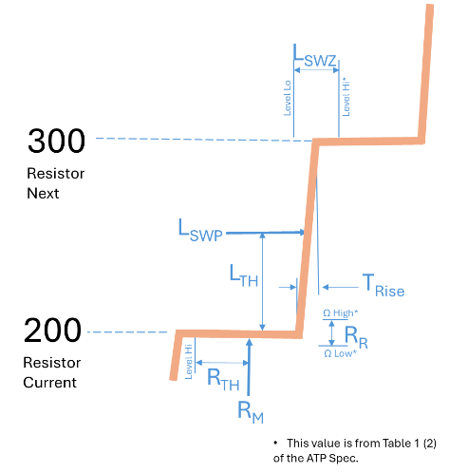
WHERE:
LSWP Level Switch Point – The next level measurement after the resistance measurement is greater than LTH during filling.
LTH Level Threshold – The average of the resistance requirement at the current level and the resistance requirement at the next level.
LSWZ Level Switch Zone – The range from Table 1 (2) within which LSWP must fall for the level to pass.
TRise Rise Time – The time measured from 110% of the current RM to 90% of the next RM.
Figure 2 Transition characteristic definitions.

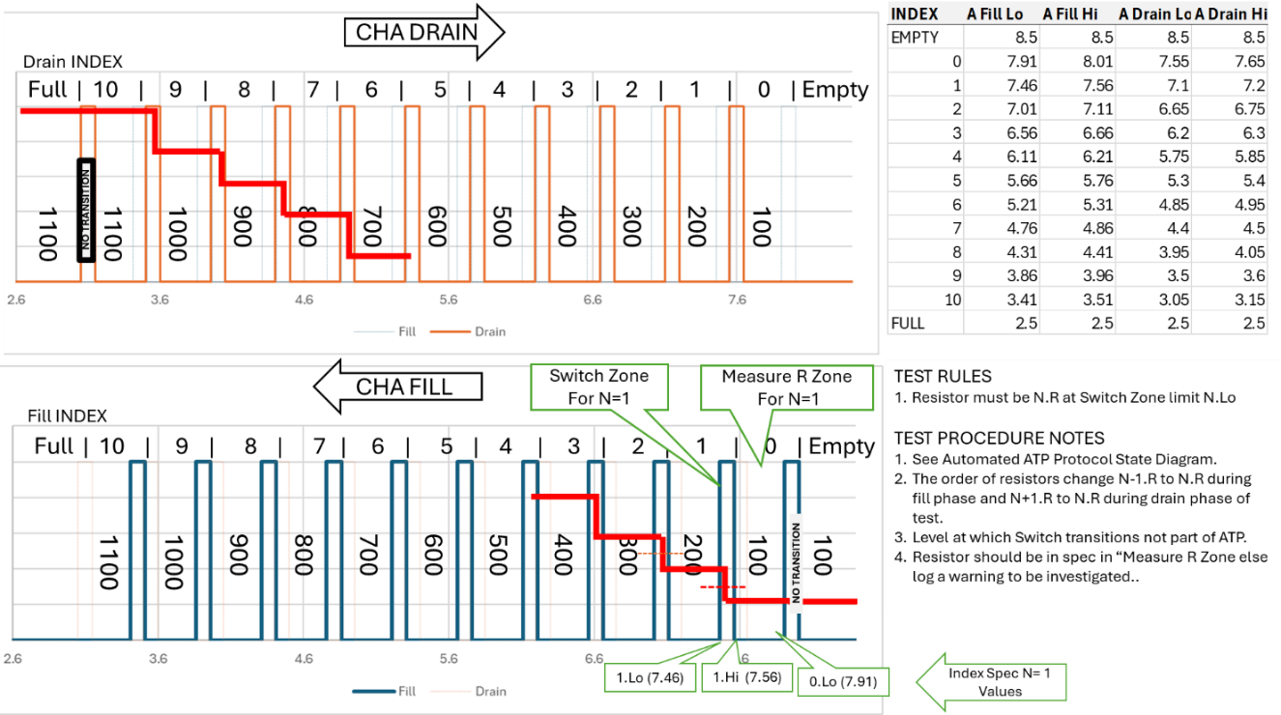
Figure 3 Illustrated Drain-Fill cycle

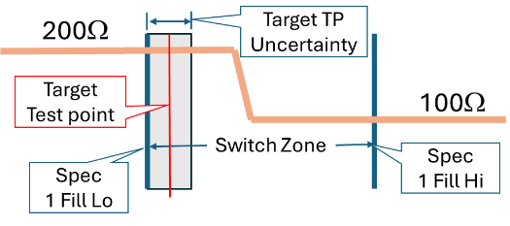
Figure 4 Determination of the Target Test Point

- The oil level shall be cycled from empty to full to empty prior to testing.
- The oil level shall be filled from empty to the Target Test Point.
- The Resistance shall be measured after any level variations subside to the specified criteria.
- If the measured resistance is within the specified tolerance, the test at this level is PASS; otherwise, a FAIL shall be logged.
- The above three steps are repeated for each Low Fill Limit alternating between measuring ChA and ChB.
- The oil level shall be drained from full to the Target Test Point.
- The Resistance shall be measured after any level variations subside to the specified criteria.
- If the measured resistance is within the specified tolerance, the test at this level is PASS; otherwise, a FAIL shall be logged.
- The above three steps are repeated for each High Drain Limit, alternating between measuring ChA and ChB.
- The DUT shall be recorded as PASS if no FAILs are recorded.
- The test status shall graphically display Ch A & Ch B resistance in ohms and display the Level in inches.
- All three traces shall be scaled so that they are overlaid at a similar size. The chart scale is a configurable test parameter.
- A display shall indicate each switch status as NOT TESTED (gray), PASS (green), FAIL (red), or ERROR (yellow) for a detected procedural problem.
- A display shall indicate the measured Target Test Point and the actual resistance measured there.
- The User must have the means to monitor the Test bench health during testing.
- Users must have a means to PAUSE the test.
- Users must have a means to ABORT the test.
- Users must have the option to RERUN the test.
- Users must have the option to run the level in manual or automatic modes.
- The default test mode is automatic.
  - Use Case 5: Generate DUT Test Report -- Production Test User
- The Test results and the Product information for each test shall be saved in one XL workbook at the option of the operator.
- The ATP Test Report shall be on one sheet labeled “ATP Report” as specified in the Report Template supplied by Engineering.
- The time in 50 ms intervals, ChA and ChB resistance in ohms, and level in inches shall be recorded and plotted on a sheet labeled “Raw Data.”
- The third sheet shall be labeled “Analysis” and include the actual level at which the Switch Point occurred (LSWP; see Figure 2).
- The sheet labeled “Analysis” shall include identification of “double actuations” (definition TBD) and slow “rise time” (definition TBD).
- The values on the Analysis sheet may be calculated post-test execution.
- EPIC 2
EPIC 2 adds the capability to test multiple PWC Elevate OLS DUTs. One DataQ has eight channels and can monitor four sensors; the tank is fixtured to accommodate 12 sensors. One DataQ is required for every four sensors. Many EPIC 1 requirements will need to be adjusted to accommodate testing multiple sensors.

- The EPIC 1 system MAY be placed into production service with the HW1 breadboard hardware.
- APPENDIX A NOT PART OF THIS SPECIFICATION
Miscellaneous Information
- The sheet shall be named the variation of the test concatenated DUT_ID
- The sheet shall be derived from the template contained in the XL test plan for the appropriate variant of the test.
- The XL Test Plan shall contain a test log of
- User must acknowledge/approve saving acquired data to Test Report.
- The path of the test report repository shall be configured by the Maintenance user.
- The user cannot change the test report or the test repository path.
- The user shall be prompted for any additional closing notes or annotations to be included.
- The first Sheet of the test report shall include Job number as Title, PRE and POST test annotations input by the user and the actual test bench configuration values for the test run.
- Each DUT test report sheet shall contain tables for each switch of:
  - Ch A Fill: in Range? Pass/Fail; Level Value of actuation.
  - Ch B Fill: in Range? Pass/Fail; Level Value of actuation.
  - Ch A Drain: in Range? Pass/Fail; Level Value of actuation.
  - Ch B Drain: in Range? Pass/Fail; Level Value of actuation.
- Each DUT test report sheet shall contain a graph of Ch A, Ch B, and level over the entire test.
- Do we want to keep a test log, perhaps as a sheet in the Test Plan that list the Job Number and general Pass/fail status?

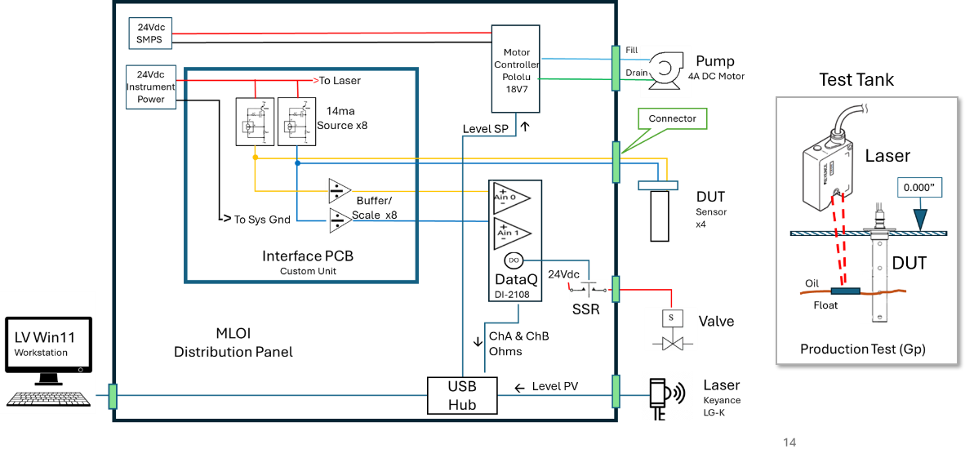
Proposed Elevation OLS Test Bench Control Hardware

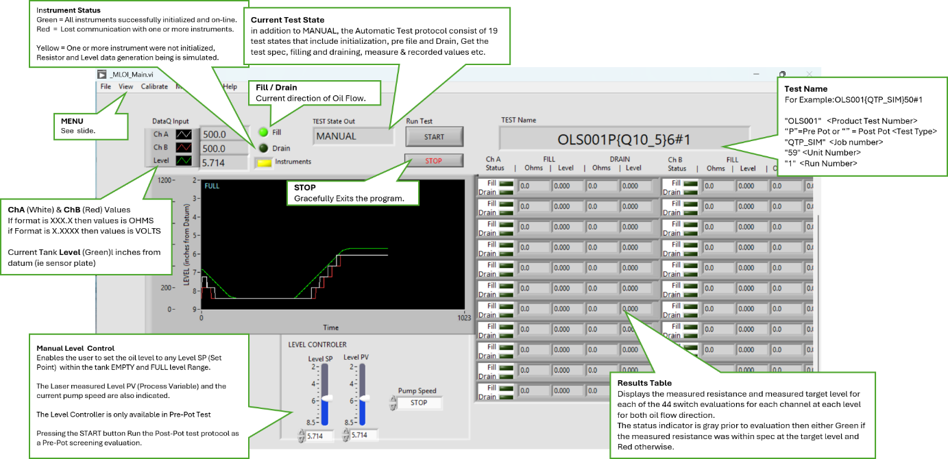
Front panel concept

